April 19th - Weekly Update

**Front-End Team [ Prasanna and Kavya ]**

* Move from one image to next image, only that image corresponding polygons to be displayed in right panel.
* Edit of group id of annotated object to be added in setup.
* Delete of the individual annotated component.
* Save as json to be added to tool.

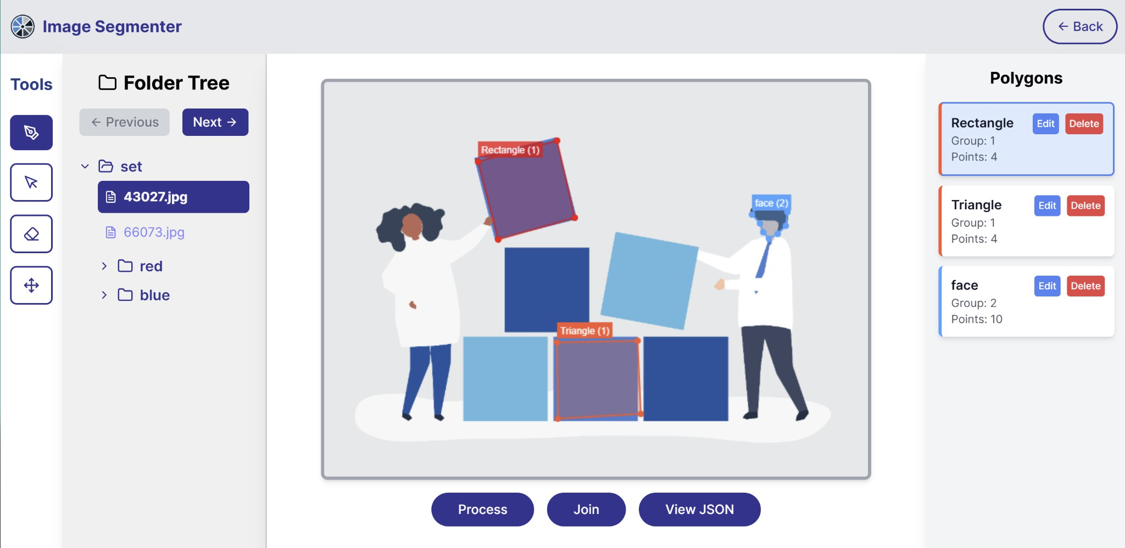

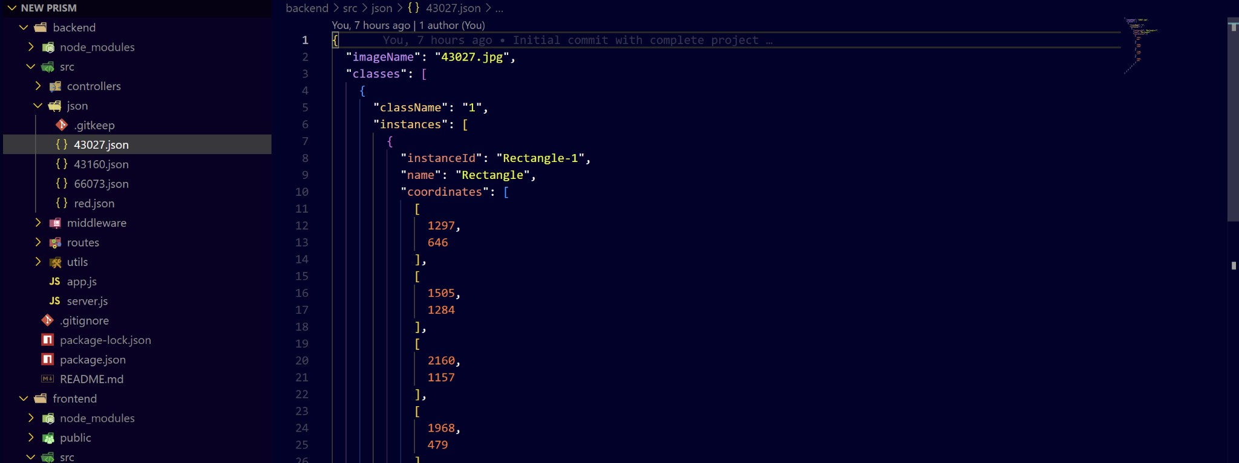Next Steps

* Once someone restarts the tool, the tool will load the json if it is already annotated and display that output.
* Zoom and unzoom operation of the canvas.
* Point to mask and mask to point facility to be added to tool.

**Back-End Team [ Aravinthakshan and Janak ]**

* Finished API for consecutive image xmem processing.

